SIMATS ENGINEERING

CO2 - ASSESSMENT TOOL 2

Scenario-Based Questions

COURSE NAME: Deep Learning COURSE CODE: MLA0408

COURSE OUTCOME COVERED

CO 2: Students will be able to apply supervised learning algorithms such as linear regression, classification models, decision trees, neural networks, support vector machines, and ensemble methods to solve real-world prediction and classification problems. They will gain the ability to select appropriate models, train them using datasets, and evaluate their performance. Students will also understand the strengths and limitations of different supervised learning approaches. (BTL-4)

CO Weightage: 15%
Assessment Tool Weightage: 40%
Duration: 90 minutes
Marks: 25

Code of Conduct:

I _K Sreelatha(192425248) (Name / Reg No) certify that this submission is my original work and that I have adhered to the guidelines specified for this assessment.
I understand that any violation of academic integrity rules will result in disciplinary action.

Signature of the student: 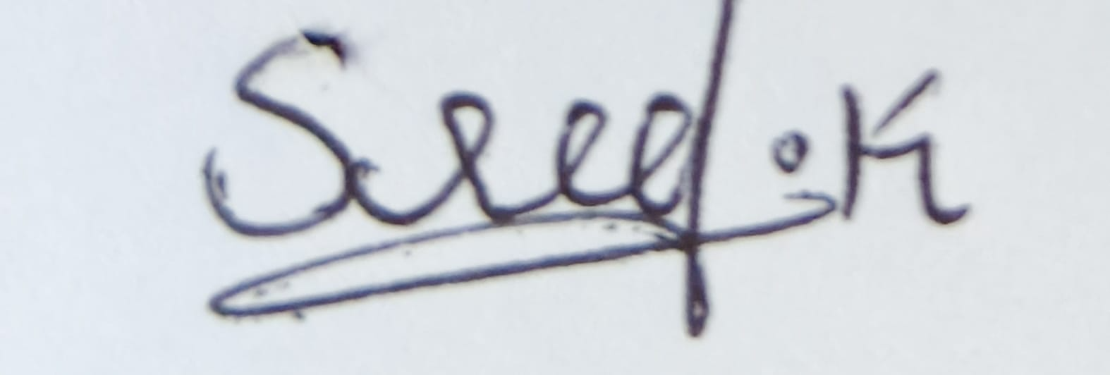

Scenario-Based Questions
CO-AT2
QUESTIONS: 05 Total Marks:25
- Unsupervised Training of Neural Networks, Auto Encoders
A hospital wants to identify abnormal ECG patterns from thousands of unlabeled records. Which deep learning technique from the syllabus would you recommend? Justify your choice and explain the workflow.

- Auto Encoders, Representation Learning
A retail company wants to reduce the dimensionality of customer purchase data before performing customer segmentation. Explain how an autoencoder can be used to solve this problem.

- Width and Depth of Neural Networks, Activation Functions
A facial recognition system performs poorly when trained using a shallow neural network. Recommend architectural changes involving network depth and activation functions.

- Restricted Boltzmann Machines (RBMs), Unsupervised Training of Neural Networks
A streaming service wants to recommend movies to users based on their viewing history without using labeled data. Explain how RBMs can be applied to build the recommendation engine.

- Deep Learning Applications, Representation Learning

A manufacturing company wants to detect defective products from sensor readings collected every second. Design a deep learning solution using concepts from representation learning and neural networks.

RUBRICS FOR CALCULATION:
Criteria | Weightage | Level 4 – Exemplary | Level 3 – Proficient | Level 2 – Developing | Level 1 – Beginning
Concept Identification | 25% | Identifies all key concepts from literature accurately and comprehensively | Identifies most key concepts with minor omissions | Identifies limited concepts; some are irrelevant or missing | Fails to identify essential concepts
Linkages | 25% | Establishes clear, meaningful, and accurate relationships between concepts | Shows correct relationships with minor gaps | Relationships are weak, unclear, or partially incorrect | No meaningful relationships established
Organization | 20% | Concepts are well-structured hierarchically with logical flow and grouping | Mostly organized with minor structural issues | Some organization but lacks clear hierarchy | No logical organization or structure
Integration of Literature | 20% | Integrates multiple studies effectively to show connections and comparisons | Shows some integration of literature | Limited integration; mostly isolated concepts | No integration of literature evidence
Clarity | 10% | Concept map is clear, neat, visually structured, and easy to interpret | Generally clear with minor readability issues | Clarity is reduced; difficult to interpret in parts | Poorly presented and hard to understand

1. Unsupervised Training of Neural Networks, Auto Encoders
Question
A hospital wants to identify abnormal ECG patterns from thousands of unlabeled records. Which deep learning technique from the syllabus would you recommend? Justify your choice and explain the workflow.
Answer
Recommended Technique
Autoencoder (Unsupervised Neural Network)
Justification
Since the ECG records are unlabeled, supervised learning cannot be used. Autoencoders learn the normal patterns in ECG signals without requiring labels. When an abnormal ECG is given, it cannot be reconstructed accurately, resulting in a high reconstruction error. This error helps detect anomalies.
Workflow
- Collect thousands of ECG signals.
- Normalize and preprocess the signals.
- Train an autoencoder using the unlabeled ECG data.
- The encoder compresses the ECG into a latent representation.
- The decoder reconstructs the original ECG.
- Calculate reconstruction error.
- ECGs with reconstruction error above a threshold are identified as abnormal.
Advantages
- No labelled data required.
- Detects unknown abnormalities.
- Reduces manual effort.
- Learns meaningful ECG features automatically.

Applications
- Heart disease diagnosis
- Arrhythmia detection
- Medical anomaly detection

2. Auto Encoders, Representation Learning
Question
A retail company wants to reduce the dimensionality of customer purchase data before performing customer segmentation. Explain how an autoencoder can be used to solve this problem.
Answer
Solution
An Autoencoder is used for dimensionality reduction by learning a compressed representation of customer purchase data.
Working
- Input customer purchase records.
- The encoder compresses the high-dimensional data into a low-dimensional latent space.
- The decoder reconstructs the original purchase data.
- After training, only the encoder is used.
- The compressed features are supplied to clustering algorithms like K-Means for customer segmentation.
Benefits
- Removes redundant information.
- Preserves important customer behavior.
- Improves clustering accuracy.
- Faster processing with reduced dimensions.
Representation Learning
The encoder automatically learns:
- Customer buying habits
- Spending patterns
- Product preferences
- Shopping frequency
Applications
- Customer segmentation
- Personalized marketing
- Product recommendation
- Sales prediction

3. Width and Depth of Neural Networks, Activation Functions
Question
A facial recognition system performs poorly when trained using a shallow neural network. Recommend architectural changes involving network depth and activation functions.
Answer
Recommended Changes
Increase Network Depth
Instead of one hidden layer, use multiple hidden layers.
Example:
Input Layer
↓
Hidden Layer 1
↓
Hidden Layer 2
↓
Hidden Layer 3
↓
Output Layer
A deeper network learns:
- Edges
- Facial features
- Eyes and nose
- Complex face patterns
Activation Functions
Use ReLU (Rectified Linear Unit) in hidden layers.
Formula:
ReLU(x) = max(0, x)
Advantages:
- Faster training
- Avoids vanishing gradient
- Better convergence
Use Softmax in the output layer for face classification.
Benefits
- Better feature extraction.
- Improved recognition accuracy.
- Learns complex facial structures.
- Handles large datasets effectively.

Applications
- Face recognition
- Biometric authentication
- CCTV surveillance
- Attendance systems

4. Restricted Boltzmann Machines (RBMs), Unsupervised Training of Neural Networks
Question
A streaming service wants to recommend movies to users based on their viewing history without using labelled data. Explain how RBMs can be applied to build the recommendation engine.
Answer
Recommended Technique
Restricted Boltzmann Machine (RBM)
Working
Input
User–Movie Rating Matrix
Example:
User | Movie A | Movie B | Movie C
U1 | 5 | 4 | ?
U2 | 3 | ? | 5
U3 | ? | 5 | 4
RBM Structure
Visible Layer
- User ratings
↓
Hidden Layer
- Learns hidden preferences
↓
Predicted Ratings
The hidden neurons discover latent factors such as:
- Action movie lovers
- Comedy lovers
- Romance lovers
The RBM predicts missing movie ratings and recommends movies with the highest predicted ratings.
Workflow
- Collect user viewing history.
- Train the RBM on the user-item matrix.
- Learn hidden user preferences.
- Predict unseen movie ratings.
- Recommend top-rated movies.
Advantages
- No labelled data required.
- Learns hidden user interests.
- Handles sparse rating matrices.
- Produces personalized recommendations.
Applications
- Movie recommendation
- Music recommendation
- E-commerce recommendations
- Video streaming platforms

5. Deep Learning Applications, Representation Learning
Question
A manufacturing company wants to detect defective products from sensor readings collected every second. Design a deep learning solution using concepts from representation learning and neural networks.
Answer
Proposed Solution
Use an Autoencoder-based Neural Network for anomaly detection.
Workflow
Sensor Data
↓
Preprocessing
↓
Encoder
↓
Compressed Features (Representation Learning)
↓
Decoder
↓
Reconstructed Sensor Data
↓
Reconstruction Error
↓
Defective or Normal Product
Working
- Collect sensor readings from normal products.
- Train an autoencoder using normal data.
- The encoder learns meaningful feature representations.
- The decoder reconstructs the sensor signals.
- Calculate reconstruction error.
- If the error exceeds a predefined threshold, classify the product as defective.
Benefits
- Detects unseen defects.
- No labelled defective data required.
- Learns important sensor patterns automatically.
- Real-time monitoring.

Applications
- Quality inspection
- Predictive maintenance
- Industrial IoT
- Smart manufacturing

